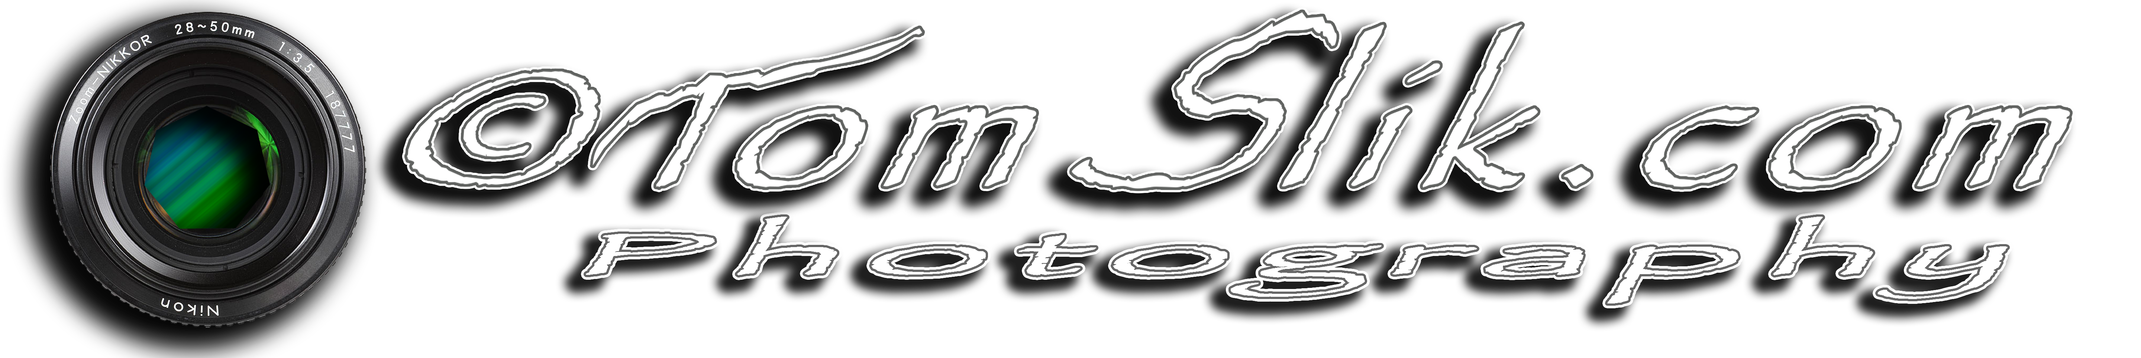Permission for Photography or Video
For valuable consideration, I grant to TomSlik.com and Tom Cantwell ("Photographer") the absolute and irrevocable right and unrestricted permission concerning any photographs or video that he has taken or may take of me or in which I may be included with others, to use, reuse, publish, and republish the photographs or video in whole or in part, individually or in connection with other material, in any and all media now or hereafter known, including the internet, and for any purpose whatsoever, specifically including online sales, illustration, promotion, art, editorial, advertising, and trade, without restriction as to alteration; and to use my name in connection with any use if he so chooses.
I release and discharge the Photographer from any and all claims and demands that may arise out of or in connection with the use of the photographs and video, including without limitation any and all claims for libel or violation of any right of publicity or privacy. This authorization and release shall also inure to the benefit of the heirs, legal representatives, licensees, and assigns of Photographer, as well as the person(s) for whom he took the photographs and video. I am a legally competent adult and have the right to contract in my own name. I have read this document and fully understand its contents. This release shall be binding upon me and my heirs, legal representatives, and assigns.

ACKNOWLEDGMENT:
MODEL NAME:
MODEL’S EMAIL ADDRESS OR PHONE:
MODEL’S MAILING ADDRESS:
IN CONSIDERATION OF HAVING RECEIVED:
IN RETURN FOR POSING ON (date):
AT (location):
MODEL’s SIGNATURE AND DATE:
PARENT/GUARDIAN SIGNATURE AND DATE:
*If the Model is under 18 years of age, a parent or legal guardian must also sign

